

24ADC001- BUSINESS INTELLIGENCE

--------------------------------------------------

2026-2027
LAB RECORD

DEPARTMENT OF ARTIFICIAL
INTELLIGENCE AND DATA SCIENCE

INDEX
Expt. No | Title of the Experiment | Page No | Total  Marks | Faculty Signature
1. | Explore the interface and basic features of the BI tool
2. | Load and visualize a sample dataset.
3. | Import a dataset into the BI tool. And Cleanse data by handling missing values, outliers, and inconsistencies.
4. | Transform data to suit BI reporting requirements and Design a dashboard with key performance indicators (KPIs).
5. | Develop interactive dashboards for dynamic data exploration.
6. | Integrate data from various sources for comprehensive analysis
7. | Implement advanced chart types (treemaps, heatmaps, etc.).
8. | Apply BI tools for forecasting and predictive analytics.

Average marks Faculty Signature

EXPT NO:1 | EXPLORE THE INTERFACE AND BASIC FEATURES OF BI Tool
DATE: 10.07.2026

PRE-LAB QUESTIONS (PROVIDE BRIEF ANSWERS TO THE FOLLOWING QUESTIONS)

- What is the purpose of Business Intelligence (BI) tools like Tableau and Power BI?
Business Intelligence (BI) tools such as Tableau and Power BI help organizations collect, analyze and visualize data to support informed decision making. They convert raw data into meaningful charts, graphs, dashboards and reports that highlight trends, patterns, and performance metrics.
These tools also allow users to interact with data through filters and additional features making it easier to monitor business performance, identify opportunities and solve problems without requiring advanced programming or technical expertise.

- List any three common data sources that Tableau and Power BI can connect to.
- Microsoft Excel files
- CSV files
- SQL databases such as MySQL

- What is a dashboard in BI, and how is it different from a single chart?
A dashboard in Business Intelligence is a collection of multiple visualizations, such as charts, tables, KPIs and filters, displayed together on one screen to provide a complete overview of business performance. Unlike a single chart, which focuses on one aspect of the data, a dashboard combines different visuals and allows interactive exploration. Users can filter, compare and analyze multiple metrics simultaneously, making dashboards more effective for monitoring and decision making.

- Define the following terms:
  - Visualization
Visualization is the graphical representation of data using charts, graphs, maps, and other visual elements. It helps users understand complex datasets, identify trends, compare values, and make informed decisions more quickly than by examining raw data.

  - KPI
A KPI is a measurable value that indicates how effectively an organization, project, or process is achieving its goals. Examples include sales revenue, profit margin, customer satisfaction, and prediction accuracy.

  - Data Filter
A data filter is a feature that displays only the data meeting specified conditions. It allows users to focus on relevant information, simplify analysis, and improve dashboard interactivity.

- Why is it important to clean and transform data before visualization?
Cleaning and transforming data ensures that visualizations are accurate, reliable and meaningful. Data cleaning removes errors, duplicates, missing values and inconsistencies that could produce misleading results. Data transformation changes the structure or format of the data to make it suitable for analysis, such as creating calculated fields or changing data types. Properly prepared data improves visualization quality, supports better decision-making and increases confidence in business insights.

- What kind of chart would you use to analyze stock price trends over time?
A line chart is the most suitable visualization for analyzing stock price trends over time. It plots stock prices against dates, making it easy to observe upward or downward movements, seasonal patterns, and sudden fluctuations. Multiple stock prices can also be displayed on the same chart for comparison. Line charts provide a clear view of changes over continuous time intervals and are widely used in financial analysis and forecasting.

- Explain the role of slicers in Power BI and filters in Tableau.
Slicers in Power BI and filters in Tableau help users interact with data by displaying only the information that matches selected conditions. Slicers provide a visual interface where users can choose categories such as stock name or date range. Tableau filters perform a similar function by limiting the displayed data based on selected values. Both features improve dashboard usability, allow focused analysis, and help users compare different data segments efficiently.

- What does a calculated field or measure do in BI tools?
A calculated field or measure performs custom calculations using existing data to generate new values for analysis. It enables users to compute metrics such as profit, growth rate, average sales, or prediction error without changing the original dataset. Calculated fields are evaluated for each row, while measures often calculate aggregated values. These features enhance dashboards by providing meaningful insights and supporting advanced reporting and business analysis.

- What are the advantages of using interactive dashboards for financial data analysis?
Interactive dashboards make financial data analysis more efficient by allowing users to explore information dynamically through filters, slicers, drill-downs, and real-time updates. They present multiple financial indicators in one place, making trends, comparisons, and anomalies easier to identify. Users can quickly analyze stock performance, prediction accuracy and trading volume without creating multiple reports. Interactive dashboards improve decision-making, save time and provide a clear understanding of financial performance.

- Which function would you use to find the absolute difference between predicted and actual stock prices?
The ABS() function is used to calculate the absolute difference between predicted and actual stock prices. It removes the negative sign and returns only the magnitude of the error.
For example, the formula ABS(Predicted Price − Actual Price) calculates the prediction error regardless of whether the prediction is higher or lower than the actual value.

IN-LAB EXERCISE:
Objective:
To understand the basic interface, data import process, and fundamental visualization capabilities of Tableau and Power BI using a stock prediction dataset, and to explore their usefulness in analyzing financial data.

Tools Required:
- Tableau Public / Tableau Desktop
- Power BI Desktop
- Sample Dataset (CSV/Excel) containing:
Date, Stock Name, Open, Close, High, Low, Volume, Predicted Price

Exercise Steps:
Part 1: Working with Tableau
- Launch Tableau and connect to the stock prediction dataset.
- Explore the Interface: o Understand components like Data Pane, Sheets, Marks Card, and Dashboards.
- Create Basic Visualizations:
  - Line Chart: Show Close Price over time. o Scatter Plot: Plot Volume vs. Predicted Price.
  - Highlight Table: Display Predicted Price by stock.
- Apply Filters:
  - Add filters for Stock Name and Date Range.
- Create Calculated Field: o Calculate prediction error as |Predicted - Close|.
- Design a Basic Dashboard:
  - Combine your charts into one interactive dashboard.

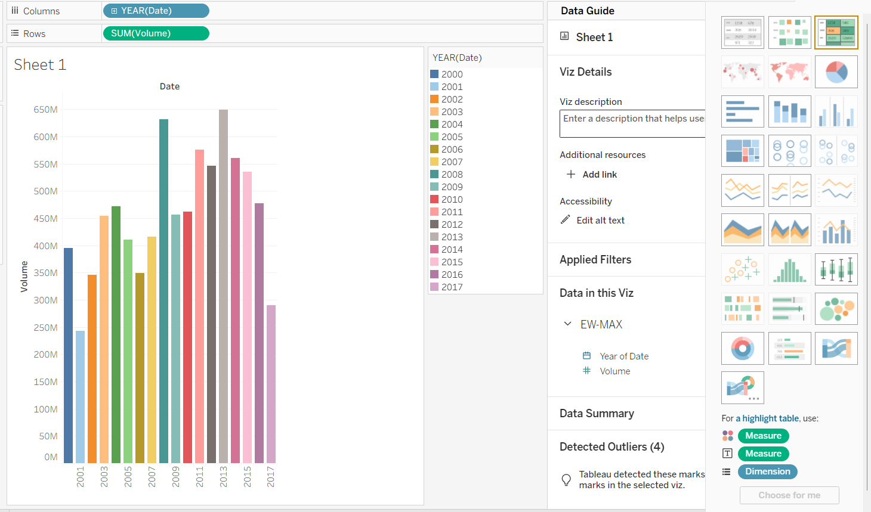
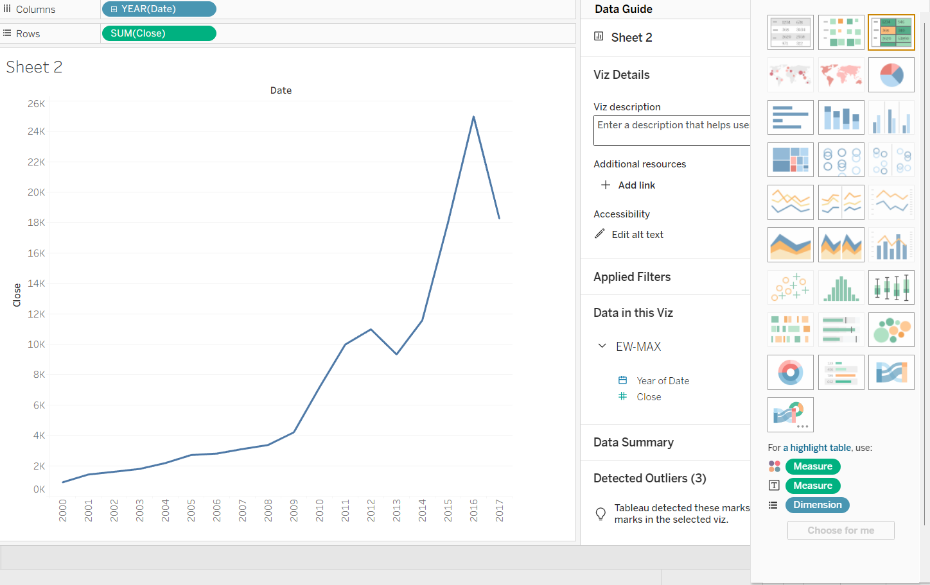
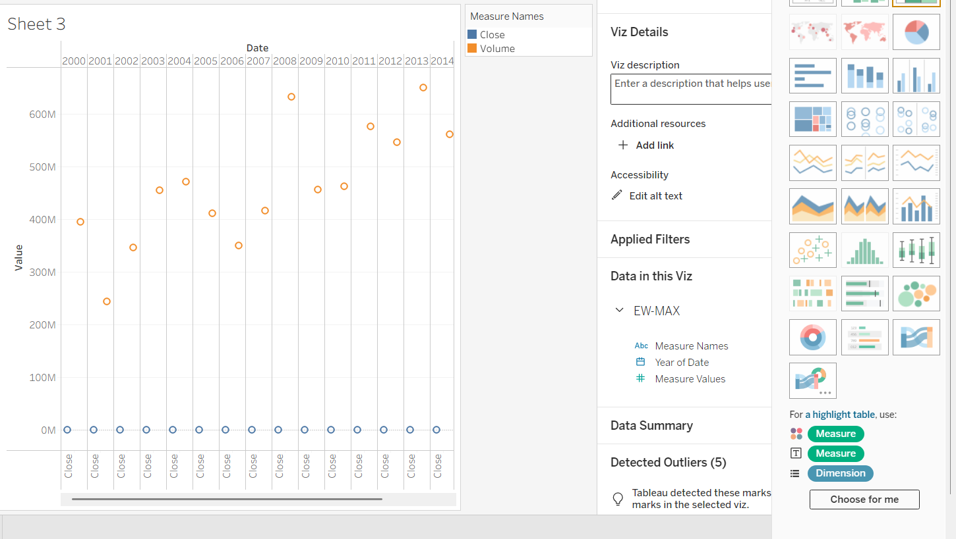

Part 2: Working with Power BI
- Open Power BI Desktop and import the same dataset.
- Explore the Interface: o Familiarize with Fields Pane, Visualizations Pane, Report View, Data View.
- Create Basic Visualizations:
  - Line Chart: Trend of Close Price over time.
  - Bar Chart: Compare Predicted Price vs. Close Price.
  - Card (KPI): Display average prediction error.
- Use Filters and Slicers:
  - Filter data based on Stock Name and Date.
- Create a Simple Measure using DAX:
  - Example: Prediction Error = ABS(Predicted - Close)
- Build a Report Page:
  - Arrange visuals in a single interactive page.

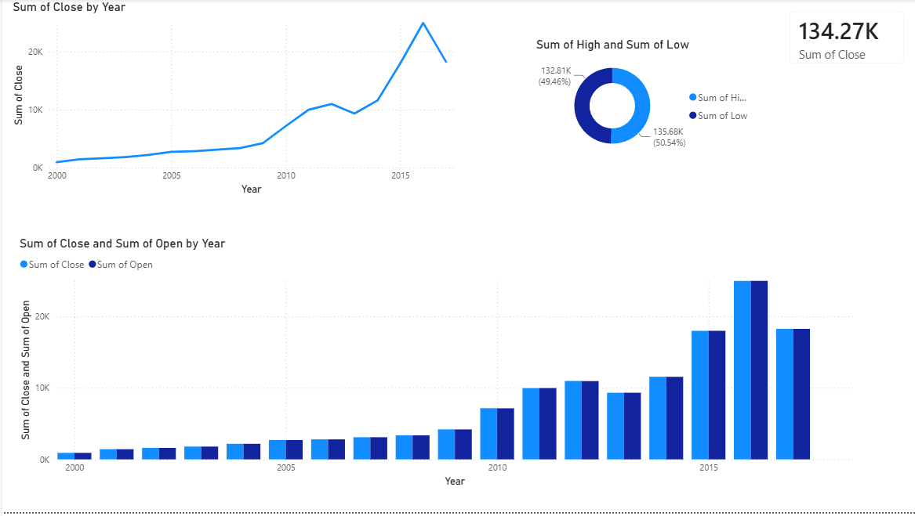

POST-LAB QUESTIONS (PROVIDE BRIEF ANSWERS TO THE FOLLOWING QUESTIONS)

- Describe your experience with the Tableau interface. What components did you interact with?
My experience with the Tableau interface was simple and interactive. I explored the Data Pane, Rows and Columns shelves, Marks Card, Filters, Worksheets, and Dashboard. These components helped me import data, create charts, apply filters, and customize visualizations. I also learned how to create calculated fields and combine multiple charts into a dashboard. The drag-and-drop interface made it easy to build visualizations without writing code, making Tableau beginner-friendly.

- How did you import the dataset into Tableau and Power BI?
In Tableau, I selected Microsoft Excel from the Connect menu, chose my dataset, and opened it in a worksheet. In Power BI, I clicked Home → Get Data → Excel Workbook, selected the same file, and clicked Load to import the data. Both tools automatically detected the columns and data types, allowing me to begin creating visualizations immediately without requiring additional data preparation.

- What types of visualizations did you create in both tools? List at least two per tool.
In Tableau, I created a Line Chart to show the trend of closing prices over time and a Scatter Plot to analyze the relationship between trading volume and closing price. I also created a highlight table for better data visualization. In Power BI, I created a Line Chart, a Clustered Column Chart comparing opening and closing prices, and KPI Cards to display average closing price and average price change.

- How did you calculate the prediction error, and how was it displayed in your dashboard?
Since my dataset did not contain predicted prices, I modified the calculation by creating a Price Change field using the formula ABS(Close – Open). In Tableau, I created it as a calculated field, while in Power BI I created it using a DAX calculated column. I displayed the average price change using a KPI Card in Power BI and included it in the dashboard along with other charts for easy analysis.

- Which filtering or slicing techniques did you apply, and what insights did they reveal?
I applied filters using Date and Volume because my dataset did not include a Stock Name column. In Tableau, I added these fields to the Filters shelf and displayed them as interactive filters. In Power BI, I used slicers for the same fields. These filters allowed me to analyze specific time periods and trading volumes, making it easier to observe price trends and identify days with unusually high or low trading activity.

- Compare the process of creating a line chart in Tableau vs. Power BI. What differences did you notice?
In Tableau, creating a line chart involved dragging the Date field to the Columns shelf and the Close field to the Rows shelf. In Power BI, I first selected the Line Chart visual and then assigned the Date and Close fields to the appropriate axes. Tableau's drag-and-drop method felt more flexible, while Power BI's predefined visual icons made it straightforward for beginners. Both tools produced clear and interactive line charts.

- How did you organize the dashboard in Tableau and Power BI? What key elements did you include?
I organized the dashboard by placing the most important visuals in a clear and logical layout. The dashboard included a line chart showing closing price trends, a scatter plot or column chart for comparison, KPI cards displaying average values, and filters or slicers for Date and Volume. This arrangement allowed users to interact with the dashboard easily and analyze different aspects of the stock data without navigating between multiple pages.

- Which tool (Tableau or Power BI) did you find more user-friendly for financial data visualization, and why?
I found Power BI more user-friendly because its interface was well-organized and the visualizations could be created quickly using the Visualizations pane. Creating KPI cards and slicers was simple, and the integration of DAX calculations was straightforward. Tableau also provided excellent visualizations and customization options, but Power BI felt easier to learn for a beginner due to its familiar layout and guided workflow.

- What challenges did you face while creating visualizations or dashboards?
The main challenge I faced was understanding the interface and deciding which fields should be assigned to different parts of each visualization. I also encountered difficulty because my dataset did not contain some columns mentioned in the lab manual, such as Stock Name and Predicted Price. I resolved this by modifying the visualizations and calculated fields to suit the available data. With practice, I became more comfortable using both Tableau and Power BI.

- How can the knowledge gained from this lab be applied to real-world financial data analysis?
The skills learned in this lab can be applied to analyzing stock market data, financial reports, and business performance. Business Intelligence tools help users identify trends, compare values, monitor key performance indicators, and make informed decisions using interactive dashboards. These techniques are widely used by financial analysts, investment firms, and business managers to analyze market behavior, evaluate company performance, and communicate insights effectively through visual reports.

ASSESSMENT

Description |  | Max Marks | Marks Awarded
Pre Lab Exercise |  | 5
In Lab Exercise |  | 10
Post Lab Exercise |  | 5
Viva |  | 10
 | Total | 30
 |  | Faculty Signature

